Carbon Emissions Analysis of Commercial Office Buildings
R Code, Statistical Methodology, and Findings
Prepared for the Kansas City Office of Sustainability
Prepared by Colin Haley
July 2026

1. Introduction and Background
The Kansas City Office of Sustainability is evaluating policies to reduce carbon dioxide emissions from large commercial office buildings. The city is specifically interested in understanding which building characteristics are most closely associated with annual emissions, and whether energy retrofits change the way building size affects emissions. This report summarizes an analysis of 120 office buildings, using their carbon emissions data to answer these questions and to inform policy recommendations.

Research Questions
- Which characteristics of commercial buildings are most closely associated with carbon emissions?
- Is an energy retrofit an effective way to reduce emissions when compared with other building characteristics?

2. Data Description
The dataset contains 120 office buildings and includes one response variable and five predictor variables, described below.
Response Variable
- Emissions_tons: annual carbon dioxide emissions, in metric tons. Quantitative, continuous.
Predictor Variables
- FloorArea_kSqFt: building size, in thousands of square feet. Quantitative, continuous.
- EnergyStarScore: energy efficiency rating. Quantitative, continuous.
- RetrofitStatus: whether the building has undergone an energy retrofit. Categorical, nominal.
  - A dummy variable, RetrofitStatusDummy, was created for this predictor, with Retrofit used as the reference category.
- TransitScore: public transit accessibility score. Quantitative, continuous.
- OccupancyRate: average annual occupancy rate. Quantitative, continuous.

3. Data Preprocessing
Before analysis, the data were cleaned and prepared as follows:
- Missing and null values were removed.
- Variables were converted to appropriate data types.
- The categorical predictor, RetrofitStatus, was converted into a dummy variable for use in the regression models.

4. Exploratory Data Analysis
Summary statistics were generated for each quantitative variable in the dataset, shown in the table below.
Variable | Mean | Standard Deviation | Minimum | Maximum
Emissions_tons | 103.1 | 72.155 | 20 | 359.3
FloorArea_kSqFt | 133.1 | 71.41 | 20.7 | 248
EnergyStarScore | 63.64 | 17.93 | 31.7 | 95
TransitScore | 56.99 | 23.14 | 22 | 99.5
OccupancyRate | 76.32 | 14.7 | 50.2 | 99.2

The R output below shows the summary statistics for the full dataset, followed by the standard deviation for each quantitative variable.
> summary(building_emissions_sustainability_Final)

BuildingID Emissions_tons FloorArea_kSqFt EnergyStarScore
Min. : 1.00 Min. : 20.0 Min. : 20.7 Min. :31.70
1st Qu.: 30.75 1st Qu.: 54.1 1st Qu.: 68.5 1st Qu.:48.62
Median : 60.50 Median : 85.7 Median :123.6 Median :62.75
Mean : 60.50 Mean :103.1 Mean :133.1 Mean :63.64
3rd Qu.: 90.25 3rd Qu.:138.4 3rd Qu.:201.2 3rd Qu.:77.30
Max. :120.00 Max. :359.3 Max. :248.0 Max. :95.00

RetrofitStatus TransitScore OccupancyRate
Length:120 Min. :22.00 Min. :50.20
Class :character 1st Qu.:35.70 1st Qu.:64.47
Mode :character Median :53.60 Median :76.40
Mean :56.99 Mean :76.32
3rd Qu.:78.30 3rd Qu.:89.38
Max. :99.50 Max. :99.20
Output of summary(building_emissions_sustainability_Final)
> sd(building_emissions_sustainability_Final$Emissions_tons)
[1] 72.15502
> sd(building_emissions_sustainability_Final$FloorArea_kSqFt)
[1] 71.40707
> sd(building_emissions_sustainability_Final$EnergyStarScore)
[1] 17.93272
> sd(building_emissions_sustainability_Final$TransitScore)
[1] 23.13546
> sd(building_emissions_sustainability_Final$OccupancyRate)
[1] 14.7012
Standard deviation calculations for each quantitative variable

5. Scatterplots and Visual Analysis
Scatterplots were generated to visually assess the relationship between emissions and each numerical predictor. The R code used to generate each plot is shown alongside the corresponding figure.
Emissions by Square Footage: Strong Positive Relationship
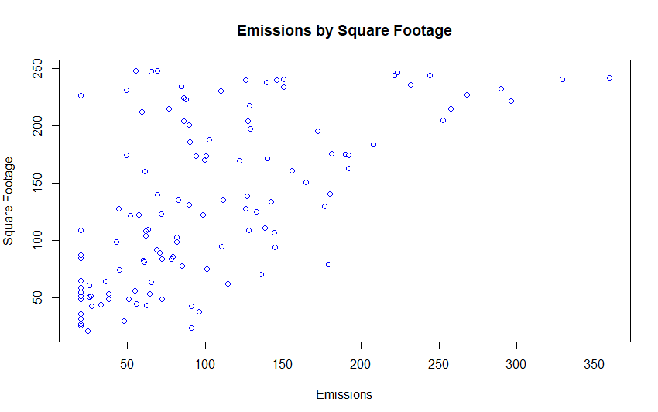
plot(building_emissions_sustainability_Final$Emissions_tons,
building_emissions_sustainability_Final$FloorArea_kSqFt,
main = "Emissions by Square Footage", xlab = "Emissions",
ylab = "Square Footage", col = "blue")
Emissions by Energy Star Score: Weak Negative Relationship
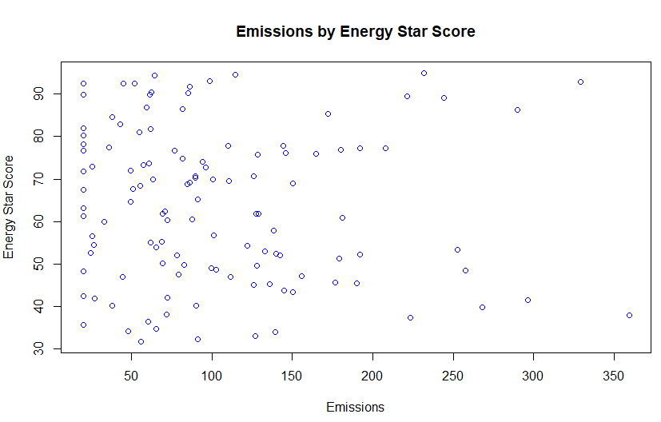
plot(building_emissions_sustainability_Final$Emissions_tons,
building_emissions_sustainability_Final$EnergyStarScore,
main = "Emissions by Energy Star Score", xlab = "Emissions",
ylab = "Energy Star Score", col = "blue")
Emissions by Transit Score: Weak Positive Relationship
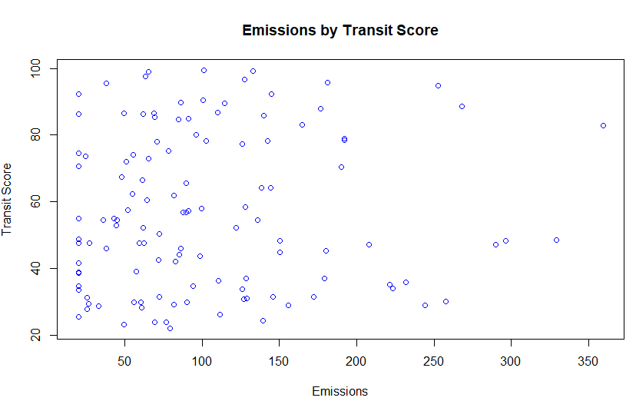
plot(building_emissions_sustainability_Final$Emissions_tons,
building_emissions_sustainability_Final$TransitScore,
main = "Emissions by Transit Score", xlab = "Emissions",
ylab = "Transit Score", col = "blue")
Emissions by Occupancy Rate: Weak Positive Relationship
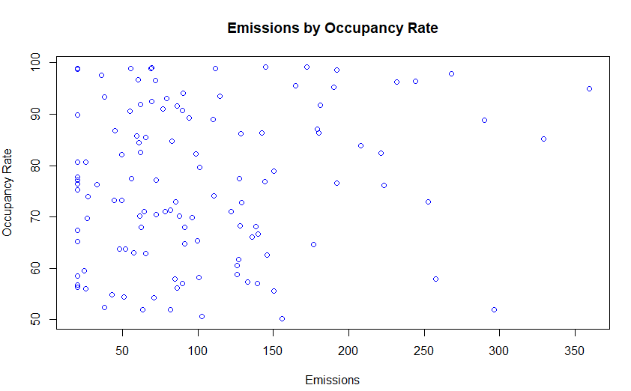
plot(building_emissions_sustainability_Final$Emissions_tons,
building_emissions_sustainability_Final$OccupancyRate,
main = "Emissions by Occupancy Rate", xlab = "Emissions",
ylab = "Occupancy Rate", col = "blue")

6. Correlation Analysis
Pairwise correlations were calculated between emissions and each numerical predictor to quantify the strength and direction of each relationship.
- Correlation between emissions and square footage: 0.6033151
cor(building_emissions_sustainability_Final$Emissions_tons,
building_emissions_sustainability_Final$FloorArea_kSqFt)
- Correlation between emissions and Energy Star Score: -0.0723184
cor(building_emissions_sustainability_Final$Emissions_tons,
building_emissions_sustainability_Final$EnergyStarScore)
- Correlation between emissions and transit score: 0.06046565
cor(building_emissions_sustainability_Final$Emissions_tons,
building_emissions_sustainability_Final$TransitScore)
- Correlation between emissions and occupancy rate: 0.1480667
cor(building_emissions_sustainability_Final$Emissions_tons,
building_emissions_sustainability_Final$OccupancyRate)

7. Simple Linear Regression
A simple linear regression model was fit using annual emissions as the response variable and building size as the sole predictor.
Regression equation: Yhat = 21.9775 + 0.60963 x (building size)
slr <- lm(Emissions_tons ~ FloorArea_kSqFt,
data = building_emissions_sustainability_Final)
summary(slr)
R code used to fit and summarize the simple linear regression model
Residuals:
Min 1Q Median 3Q Max
-139.88 -33.30 -11.88 36.80 189.91

Coefficients:
Estimate Std. Error t value Pr(>|t|)
(Intercept) 21.97750 11.19245 1.964 0.0519 .
FloorArea_kSqFt 0.60963 0.07419 8.218 3.04e-13 ***
---
Signif. codes: 0 '***' 0.001 '**' 0.01 '*' 0.05 '.' 0.1 ' ' 1

Residual standard error: 57.79 on 118 degrees of freedom
Multiple R-squared: 0.364, Adjusted R-squared: 0.3586
F-statistic: 67.53 on 1 and 118 DF, p-value: 3.04e-13
Output of summary(slr)
Slope Interpretation
For every one square foot increase in building floor area, total emissions are estimated to increase by 0.60963 tons, holding all else constant.
R-squared Interpretation
The R-squared value for this model is 0.364, meaning that 36.4 percent of the variation in emissions can be explained solely by the square footage of the building being analyzed.
Model Sufficiency for Policy Decisions
Based on the model output, this simple linear regression model is not sufficient on its own for sustainability policy decisions. Because the model relies on a single predictor, it explains only 36.4 percent of the variability in emissions. Additional predictors are needed to build a more reliable model that captures more of the variation in emissions.

8. Multiple Regression: Main Effects Model
A multiple regression model was fit using annual emissions as the response variable and all available predictors, referred to as the main effects model.
Regression equation: Yhat = 70.937 + 0.70045 x (square footage) - 0.61628 x (Energy Star Score) - 69.88 x (No Retrofit) - 0.18029 x (transit score) + 0.28365 x (occupancy rate)
RetrofitDummy <- model.matrix(~RetrofitStatus,
data = building_emissions_sustainability_Final)

Model1 <- lm(Emissions_tons ~ FloorArea_kSqFt + EnergyStarScore +
RetrofitStatus + TransitScore + OccupancyRate,
data = building_emissions_sustainability_Final)
summary(Model1)
R code used to fit and summarize the main effects model
Residuals:
Min 1Q Median 3Q Max
-91.750 -35.489 -0.169 23.128 135.972

Coefficients:
Estimate Std. Error t value Pr(>|t|)
(Intercept) 70.93687 30.23819 2.346 0.0207 *
FloorArea_kSqFt 0.70045 0.06157 11.376 < 2e-16 ***
EnergyStarScore -0.61628 0.24113 -2.556 0.0119 *
RetrofitStatusRetrofit -69.88649 8.98201 -7.781 3.56e-12 ***
TransitScore -0.18029 0.19057 -0.946 0.3461
OccupancyRate 0.28365 0.29555 0.960 0.3392
---
Signif. codes: 0 '***' 0.001 '**' 0.01 '*' 0.05 '.' 0.1 ' ' 1

Residual standard error: 46.66 on 114 degrees of freedom
Multiple R-squared: 0.5994, Adjusted R-squared: 0.5818
F-statistic: 34.11 on 5 and 114 DF, p-value: < 2.2e-16
Output of summary(Model1)
Coefficient Interpretations
- Square footage: for each one unit increase in square footage, total emissions increase by 0.70045 tons, holding other variables constant.
- Energy Star Score: for each one unit increase in Energy Star Score, total emissions decrease by 0.61628 tons, holding other variables constant.
- Retrofit status: a retrofitted building is associated with a 69.88 ton decrease in total emissions compared with a building that has not been retrofitted.
- Transit score: for each one unit increase in transit score, total emissions decrease by 0.18029 tons, holding other variables constant.
- Occupancy rate: for each one unit increase in occupancy rate, total emissions increase by 0.28365 tons, holding other variables constant.
- Intercept: if all other predictors were zero, total emissions would equal 70.93687 tons. This value has limited practical use, since it does not correspond to any real building and is not a meaningful figure for the purposes of this analysis.
Statistical Significance
Square footage, Energy Star Score, and retrofit status are all statistically significant predictors at the 0.05 significance level.
Effect of Retrofit Status
After controlling for the other variables in the model, retrofit status continues to be associated with a meaningful reduction in emissions. Using the dummy variable created for this predictor, with Retrofit as the reference category, the model estimates that retrofitted buildings produce approximately 69.88 fewer tons of emissions than buildings that have not been retrofitted.

9. Interaction Model: Does Retrofit Moderate the Size Effect?
The city is especially interested in whether the effect of building size on emissions differs for retrofitted buildings. To evaluate this, a multiple regression model was fit that includes all available predictors, retrofit status, and an interaction term between floor area and retrofit status.
Regression equation: Yhat = 37.30354 + 1.12474 x (square footage) + 36.99 x (retrofit) - 0.62373 x (Energy Star Score) - 0.03592 x (transit score) - 0.05466 x (occupancy rate) - 0.79772 x (interaction between square footage and retrofit)
Model2 <- lm(Emissions_tons ~ FloorArea_kSqFt * RetrofitStatus +
EnergyStarScore + TransitScore + OccupancyRate,
data = building_emissions_sustainability_Final)
summary(Model2)
R code used to fit and summarize the interaction model
Residuals:
Min 1Q Median 3Q Max
-93.262 -23.724 -4.953 22.058 116.793

Coefficients:
Estimate Std. Error t value Pr(>|t|)
(Intercept) 37.30354 24.71012 1.510 0.13392
FloorArea_kSqFt 1.12474 0.07293 15.421 < 2e-16 ***
RetrofitStatusRetrofit 36.99425 15.29438 2.419 0.01717 *
EnergyStarScore -0.62373 0.19412 -3.213 0.00171 **
TransitScore -0.03592 0.15450 -0.232 0.81659
OccupancyRate -0.05466 0.24173 -0.226 0.82151
FloorArea_kSqFt:RetrofitStatusRetrofit -0.79772 0.10059 -7.931 1.71e-12 ***
---
Signif. codes: 0 '***' 0.001 '**' 0.01 '*' 0.05 '.' 0.1 ' ' 1

Residual standard error: 37.57 on 113 degrees of freedom
Multiple R-squared: 0.7426, Adjusted R-squared: 0.729
F-statistic: 54.34 on 6 and 113 DF, p-value: < 2.2e-16
Output of summary(Model2)
Interpretation of Key Coefficients
- Square footage: for each one unit increase in square footage, total emissions increase by 1.12474 tons, holding other variables constant.
- Retrofit status: for a retrofitted building, emissions increase by 36.99425 tons compared with a building that has not been retrofitted, before accounting for the interaction with square footage.
- Interaction between retrofit and square footage: for retrofitted buildings, the slope of the square footage relationship is reduced by 0.79772 compared with non-retrofitted buildings, meaning that the emissions benefit of a retrofit grows as building size increases.
Statistical Significance of the Interaction
The interaction term has a p-value of 1.71e-12, which is statistically significant at the 0.05 significance level.
Implications for Retrofit Value by Building Size
The negative coefficient of -0.79772 on the interaction term indicates that a retrofit has an increasingly positive effect on reducing emissions as square footage increases. In other words, the larger the building, the more emissions a retrofit is likely to reduce compared with a smaller building.

10. Policy Interpretation of Retrofits
Using the interaction model, the marginal effect of a retrofit was calculated for a building with a floor area of 150,000 square feet (FloorArea_kSqFt = 150).
Marginal effect of retrofit:
Yhat = 36.99425 + (-0.79772 * 150)
Yhat = -82.66375
Interpretation
Based on this calculation, applying a retrofit to a 150,000 square foot building would be expected to decrease emissions by approximately 82.66 tons.
Influence on City Retrofit Incentives
A reduction of more than 80 tons of emissions for a large building of this size should strongly influence the city to incentivize retrofit programs. This finding shows that retrofits deliver substantially greater emissions reductions in large buildings, which makes incentive programs targeted at large buildings a particularly effective use of city resources.

11. Prediction and Uncertainty
Using the interaction model, annual carbon dioxide emissions were predicted for a building with the following characteristics:
- Floor area: 150,000 square feet
- Energy Star Score: 80
- Retrofit status: Yes
- Transit score: 85
- Occupancy rate: 90 percent
Yhat = 37.30354 + (1.12474 * 150) + (36.99425 * 1) + (-0.62373 * 80)
+ (-0.03592 * 85) + (-0.05466 * 90) + (-0.79772 * 150 * 1)

Yhat = 168.711 + 36.99425 - 49.8984 - 3.0532 - 4.9194 - 119.658

Yhat = 65.48 tons of emissions
Predicted emissions calculation for the specified building profile

12. Conclusion and Recommendations
Across the models tested, square footage and retrofit status emerged as the two strongest drivers of carbon emissions among commercial office buildings in this dataset. Square footage was consistently associated with higher emissions, while retrofit status was consistently associated with lower emissions, and the interaction model shows that this emissions reduction becomes larger as building size increases.
Retrofit Effectiveness
Retrofits have a positive impact on reducing carbon emissions, and this impact scales with building size. Larger buildings see a greater emissions benefit from retrofit upgrades than smaller buildings, where retrofits appear to be less effective in reducing emissions.
City Planning Recommendations
- For buildings larger than 100,000 square feet, prioritize retrofit programs, since retrofits produce the greatest emissions reductions in this size range.
- For smaller buildings, focus policy efforts on reducing square footage or improving space efficiency rather than mandating retrofits, since the emissions benefit of retrofits is smaller at this scale.
- Consider using Energy Star Score as an additional variable when identifying buildings most likely to reduce emissions, since higher scores are associated with lower emissions.

